CSA1515 CLOUD COMPUTING
Lab programs EXP :12 -16
NAME: VIGNESHWAR.D
REG.NO: 192524415

12. Demonstrate virtualization by Installing Type-2 Hypervisor in your device, create and configure VM image with a Host Operating system
(Either Windows/Linux).

AIM:
To create a virtualization by Installing Type-2 Hypervisor in your device, create and configure VM image with a Host Operating system.

PROCEDURE:
• Open VirtualBox
• Click New.
• Enter VM Name
• Example: Ubuntu VM
• Select ISO Image
• In ISO Image, click the
drop-down / Browse option.
• Select your downloaded Ubuntu
.iso file.
• Select OS Type
• VirtualBox usually detects the OS
automatically.
• Example: Linux → Ubuntu
(64-bit).

• Configure Hardware
• RAM: 2–4 GB
• CPU: 2 processors

IMAGE:
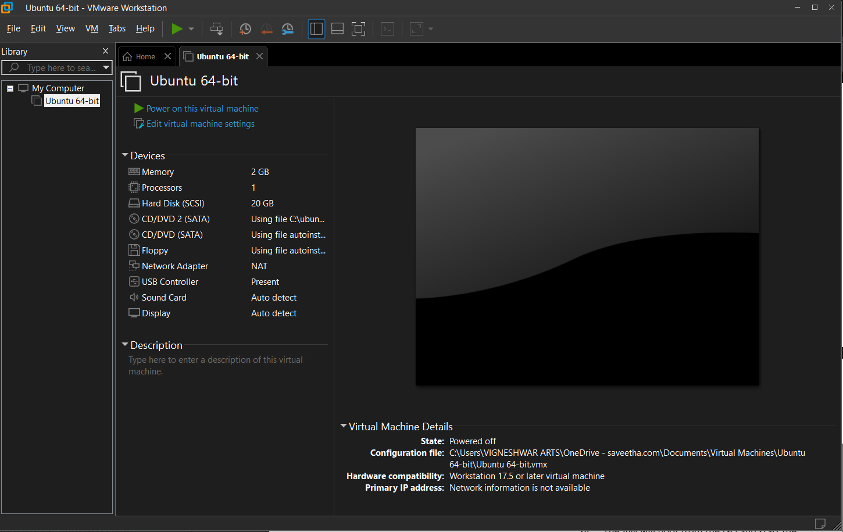

13. Create a Virtual Machine with 1 CPU, 2GB RAM and 15GB storage disk
using a Type 2 Virtualization Software.

AIM:
To Create a Virtual Machine with 1 CPU, 2GB RAM and 15GB storage disk
using a Type 2 Virtualization Software.

PROCEDURE:
1. Open VMware Workstation.
2. Click Create a New Virtual Machine.
3. Select Typical (Recommended) and click Next.
4. Select Installer disc image file (ISO).
5. Click Browse and select the Ubuntu/Linux ISO file.
6. Enter the VM details:
1. Virtual Machine Name: Ubuntu-VM
2. Select the location where you want to save the VM.
7. Set the Disk Size:
1. Enter 15 GB.
2. Select Store virtual disk as a single file.
8. Click Customize Hardware.
9. Set Memory:
1. 2 GB (2048 MB)
10. Set Processors:
• Number of processors: 1

IMAGE:
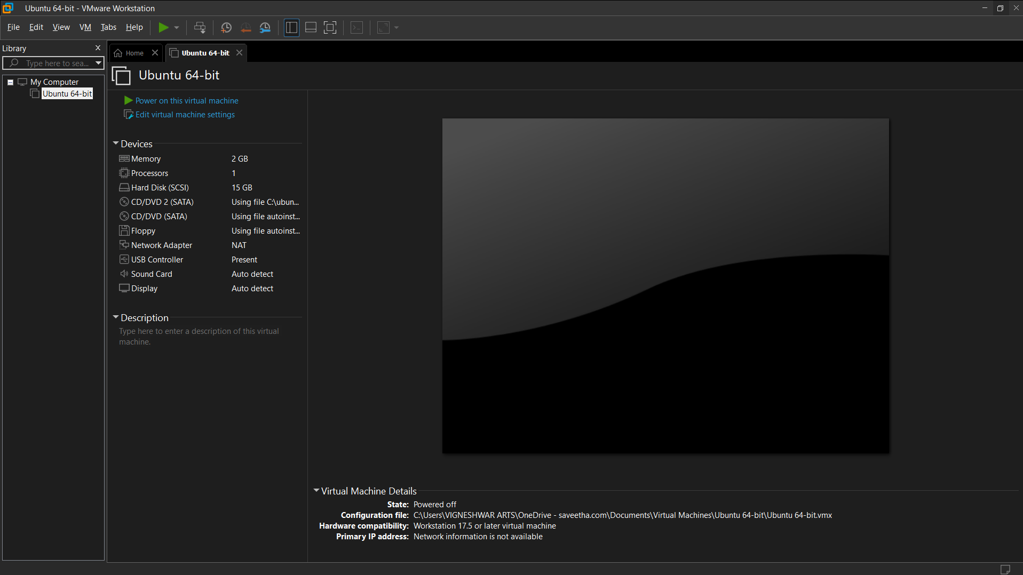

14. Create a Virtual Hard Disk and allocate the storage using VM ware
Workstation

AIM:
To Create a Virtual Hard Disk and allocate the storage using VM ware
Workstation

PROCEDURE:
• Open VMware Workstation.
• Click Create a New Virtual Machine.
• Select Typical (Recommended) → click Next.
• Select I will install the operating system later → Next.
• Select the Guest Operating System and click Next.
• Enter a Virtual Machine Name and choose the storage
location.
• In Specify Disk Capacity, enter the required storage size.
• Example: 15 GB
• Select Store virtual disk as a single file.
• Click Next → Finish.
• The Virtual Hard Disk (.vmdk) will be created and allocated
to the VM.

IMAGE:
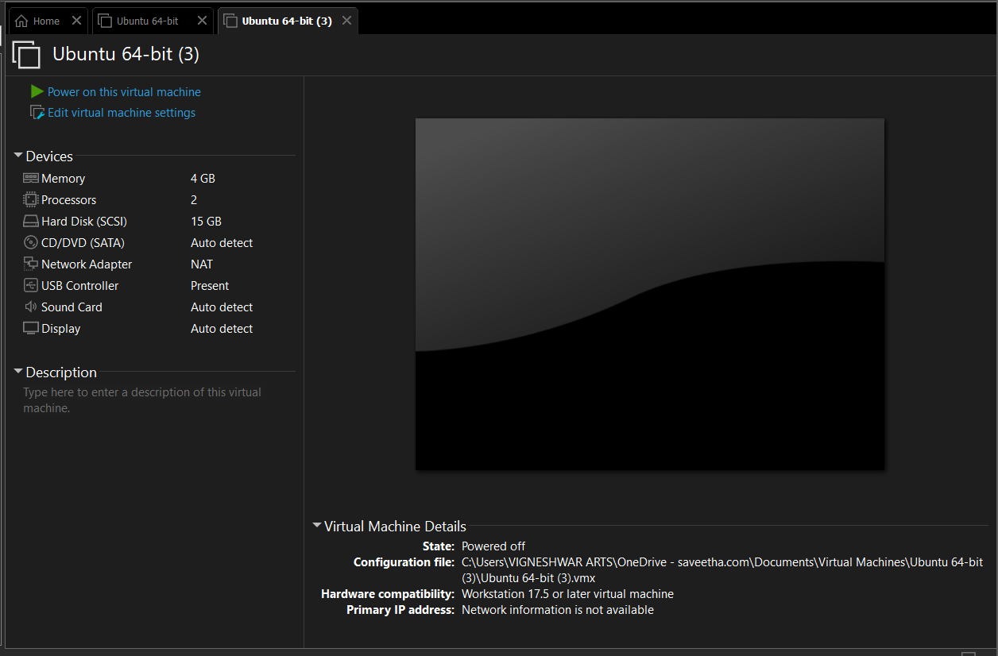

15. Create a Snapshot of a VM and Test it by loading the Previous
Version/Cloned VM.

AIM:
To Create a Snapshot of a VM and Test it by loading the Previous
Version/Cloned VM.

PROCEDURE:
• Open VMware Workstation.
• Start your Virtual Machine and make sure the guest OS is
working.
• Create a Snapshot
• Go to VM → Snapshot → Take Snapshot.
• Enter a name, e.g., Before Changes.
• Click Take Snapshot.
• Make Changes to the VM
• Create a new folder/file.
• Install a small application or change a setting.
• This represents changes made after the snapshot.
• Test the Snapshot
• Go to VM → Snapshot → Snapshot Manager.
• Select Before Changes.
• Click Go To / Restore.
• Confirm the Previous State
• Start or restart the VM if required.
• Check whether the changes made after the snapshot
have been removed.

IMAGE:
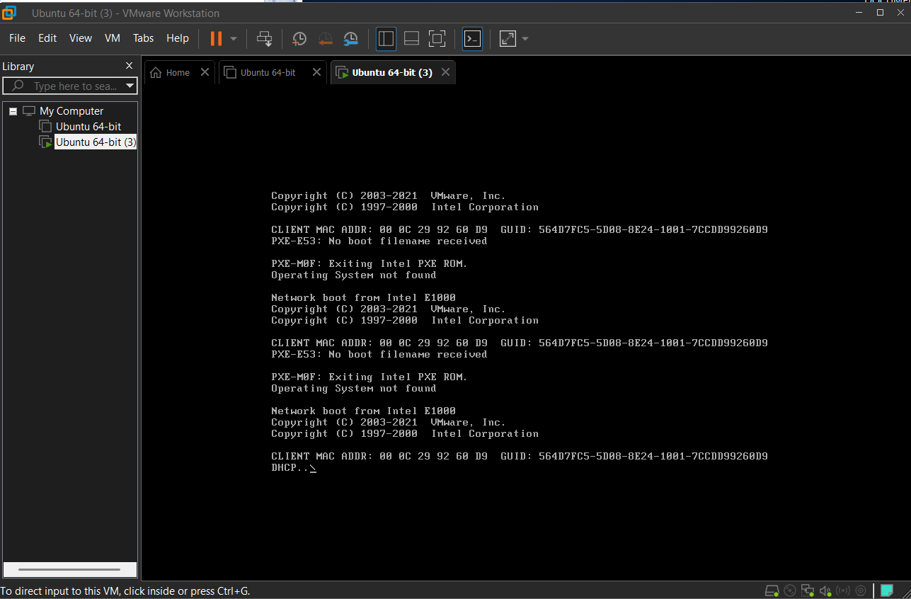

16. Create a Cloning of a VM and Test it by loading the Previous
Version/Cloned VM

AIM:
To Create a Cloning of a VM and Test it by loading the Previous
Version/Cloned VM

PROCEDURE:
Clone the VM
1. Power off the VM.
2. Go to VM → Manage → Clone.
3. Select the snapshot as the cloning point.
4. Choose Create a Full Clone.
5. Give the cloned VM a new name.
6. Click Finish.
7. Start the cloned VM and verify that it contains the previous
VM state.

IMAGE:
